# JDI User Guide

When you debug your program with JDI emulator, please ensure the JDI and the target device is connected: please use a micro-b USB cable to connect JDI and you PC. And use the JTAG cable to connect your board.

**[补图]**

The JTAG connector in JDI is descripted in following figure:

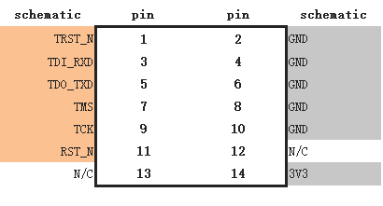

Please make sure the TDI/TDO/TMS/TCK and RST_N, GND are connected correctly.

When connecting JDI emulator to PC, an USB device should be found in PC side. Please install the JDI driver, which is located in IngenicStudio\tools\JDI Pro folder. If you use Win10, please make sure PC turn off the driver digital signature. When the JDI driver installed successfully, there is a virtual network card in device list of your PC, for example:

**[最好更新图，更换成英文图]**

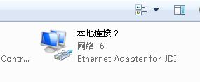

Please view the attribution of this network device and record the IP address,

eg:

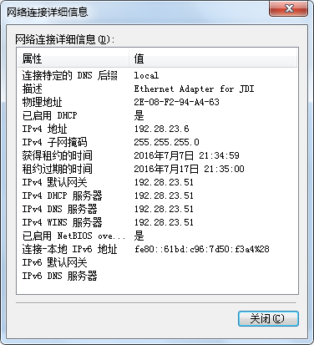

## Setup Debug Environment

Open Ingenic Studio, in the menu: Run-> Debug Configurations…

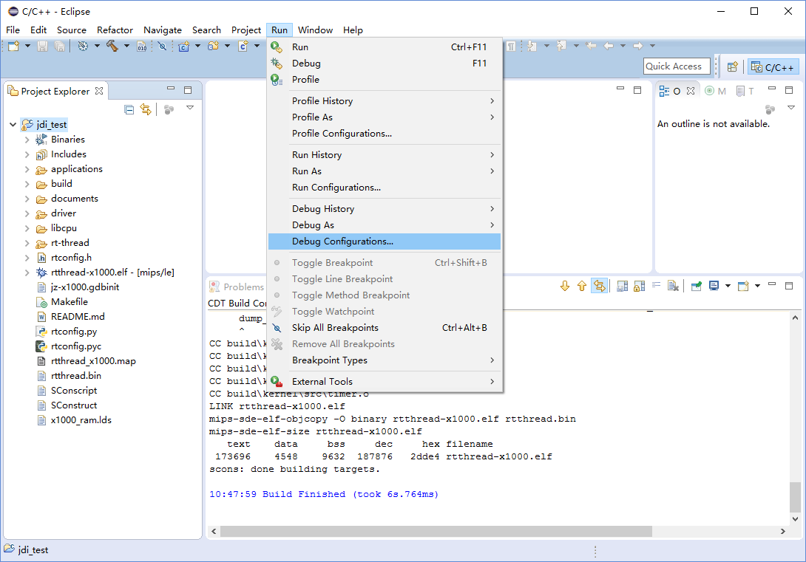

In the debug Configurations dialog, please select “Zylin Embedded debug (Native)” and then double-click it.

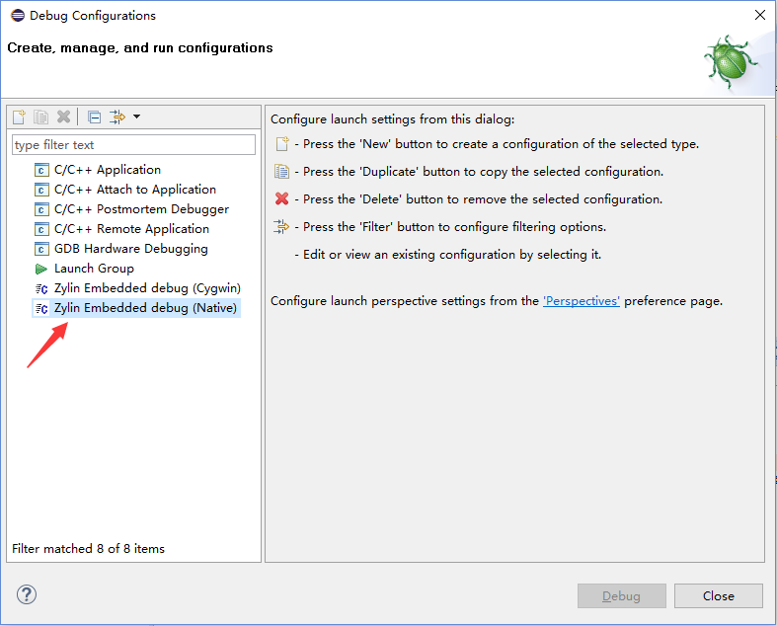

Then it will create a new configuration:

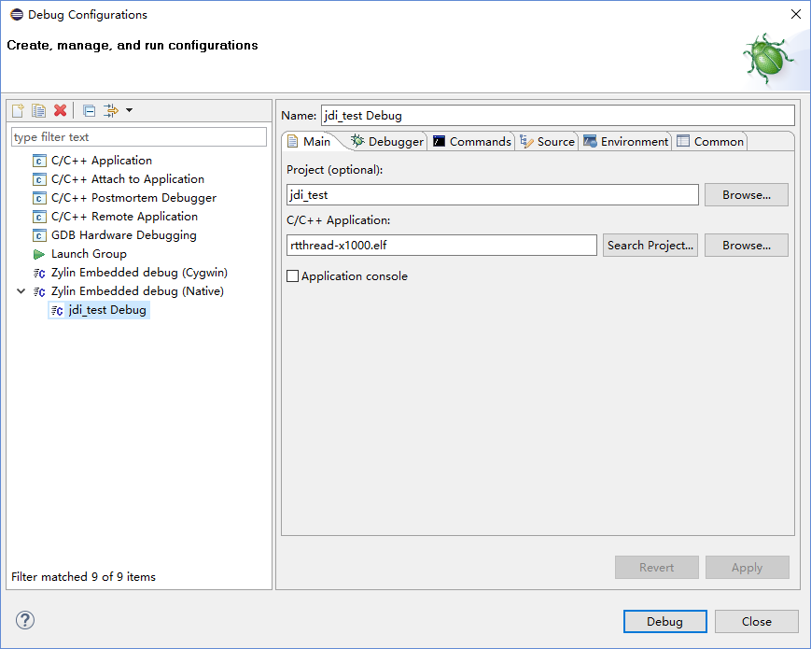

In the Debugger tab page, you should setup gdb.exe and the GDB initialization script file path.

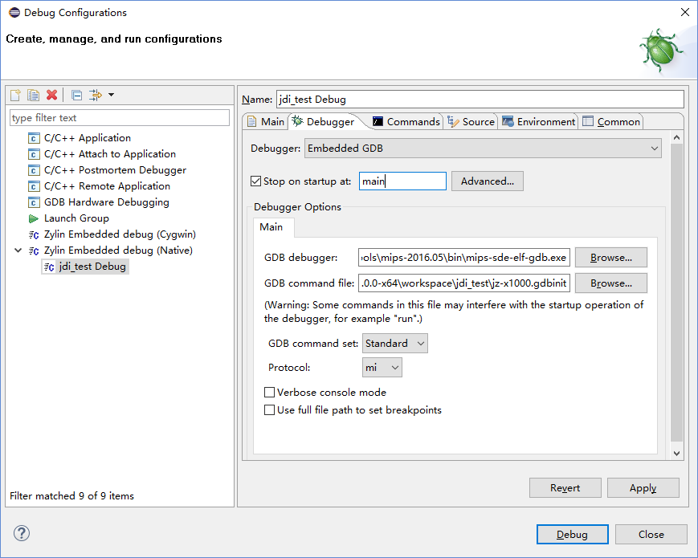

* The “mips-sde-elf-gdb.exe” is placed in Ingenic Studio\tools\mips-2016.05\bin folder.
* The “jz-x1000.gdbinit” is placed in your workspace folder.

In convenience, you can let the debug item display in favorites menu (In Common tab page), selected the “Debug” item.

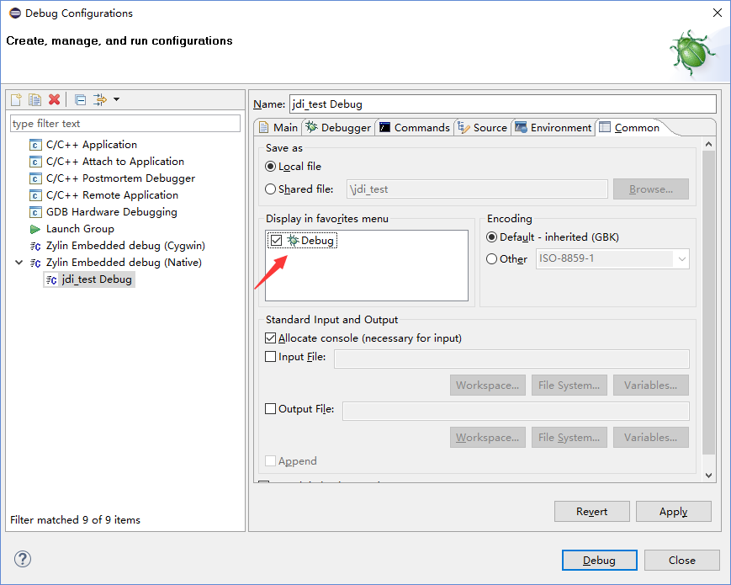

Then you can click “Close” button and confirm the configuration by “Yes” button:

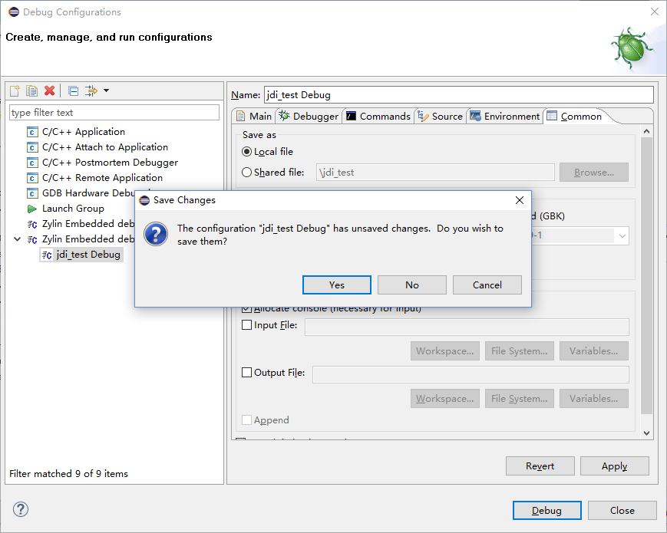

## The GDB initialization script

The jz-x1000.gdbinit is the gdb initialization script when gdb starting. You can open it in Ingenic Studio editor:

# connect to the JDI gdb server

target remote 192.28.23.51:2823

set remotewritesize fixed

set endian little

set mipsfpu double

#load the debug image

load

#debug begin

Please pay attention in the red font part, the “192.28.23.51:2823” is the JDI emulator IP address. The “192.28.23.51” is the gateway address in new virtual network interface card and “2823” is the “GDB server” port in the JDI emulator.

## Startup Debug

Please click your new created debug configuration item, for example, “jdi_test Debug”:

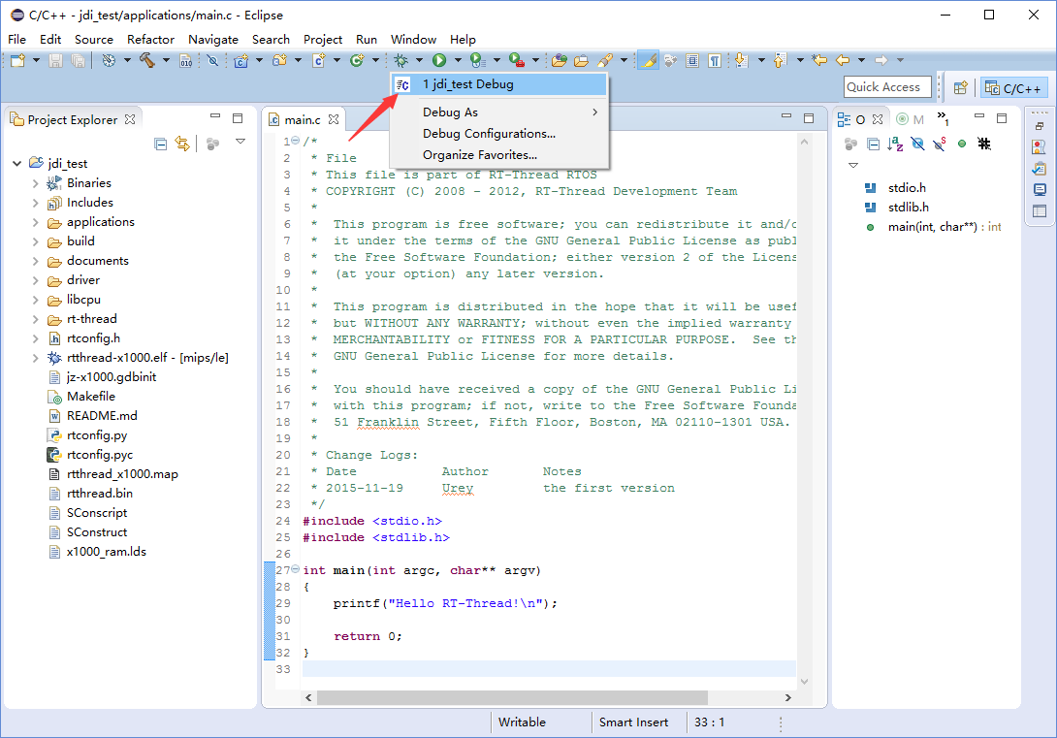

There is a confirm dialog to confirm whether switch to Debug perspective, please click “Yes” button.

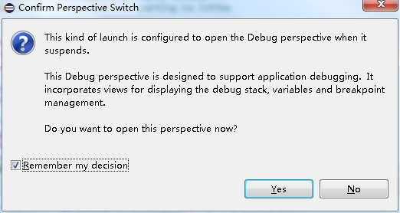

When JDI emulator connected successfully, the UI likes that:

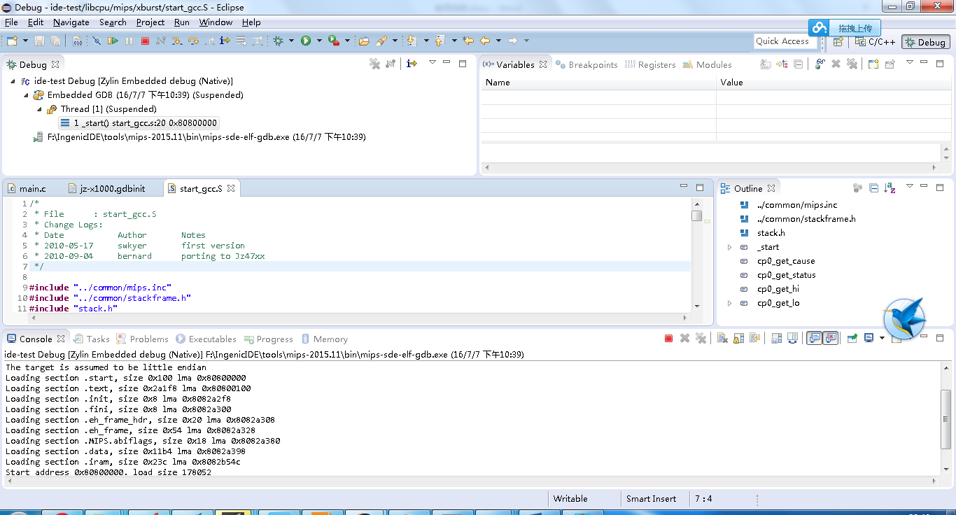

Then you can debug your program, such as step in/step over, or inspect variable, function call stack etc.